**Serial Position Effects:**

**A phenomenon of memory in which items presented at the beginning and end of a list are more likely to be recalled than items in the middle of a list.**

First encounters and last words each have a unique influence on our ability to remember information. This phenomenon is captured in the design principle known as the Serial Position Effect, which states that items presented at the beginning and end of a list are more likely to be recalled than items in the middle of a list. This principle capitalizes on two different memory concepts. The primacy effect dictates that items at the beginning of a list of items are more likely to be accurately recalled than items in the middle, and [research](https://msu.edu/~ema/802/Ch6-Memory/1/GlanzerCunitz66.pdf) has shown that these items are more likely committed to long-term memory. This also seems to impact how we [view and categorize](https://psychology.iresearchnet.com/social-psychology/social-cognition/primacy-effect-in-attribution/) people when we first meet them, hence the importance of first impressions. Conversely, the recency effect states that items at the end of the list are also better remembered than items in the middle, but these items are better accessed via short term memory. We can see this effect in our daily lives when we can recall what someone just said to us, but not the words just preceding them. For example, when a waiter reads the list of items to us you may be able to remember the first and last special they mentioned, but not the middle one. To maximize the use of these concepts one might put more immediate action items towards the end of a list, or sequence, and items to be acted upon or recalled later would be best served at the beginning of the list.

The serial position effect is particularly important in the design and execution of education and training programs because it impacts efficacy and should be considered for course time blocks, content placement, and information presentation, as well as feedback and memory consolidation. The effect concerns both the attention of and engagement by the student. When immediately presented with information, our attention is drawn, and processing occurs. Subsequent information may [not be attended](https://www.verywellmind.com/what-is-inattentional-blindness-2795020) to due to the processing of the initial information, which is where the lull occurs. As our attention is then redirected to the end of the list, we process, engage, and consequentially can better recall the end of list information. The concept strongly aligns with [UDL](http://udlguidelines.cast.org/) principles of Sustaining Effort & Persistence, Comprehension, and Executive Functions. We are well served when our designs and execution emphasize what matters most at appropriate times, hence leveraging primacy and recency effects to maximize memory transfer and to support organization and consolidation of information. We can more easily accomplish these tasks by incorporating other principles of design such as advance organizers, chunking, and nudges. Regardless of the specific techniques utilized, it is incumbent on the designer and facilitator to exploit the utility of these effects while offsetting the consequences of the middle lull. Doing so increases the likelihood of achieving the desired learning outcome.

**Great speeches often use and offset the effects**

One of the best examples I can think of for both utilizing the strengths of the serial position effect and to offset its drawback is through an effective speech or lecture. Perhaps the most memorable speech of the modern era does just that. What's interesting about this speech in particular, among several things, is that the most memorable part for many happens in the middle. It begins with statements of fact and ends with a clarion call to action, but it's what happens in the middle that has moved millions. We may not all be able to speak with such power but we can learn from the effectiveness of its mechanics.



**Manipulate sequence to manipulate the effects**

Flashcards are a common study technique used to help memorize information. To make using them more effective we can add color and imagery. We also want to ensure that we offset the serial position effect by mixing the cards up so that we remember each card equally well. We can manipulate the effect both within the card and within the deck. A bonus hack may be to view the most difficult cards one last time before the test.



**Emphasize key instructions at beginning and end**

Game instructions or another example of when we need to be cognizant of this serial position effect. Here we see that Candyland does a couple of things keeping the effect in mind. It clearly states the objective at the top(primacy), highlighted by itself. In the same column, at the end of the instructions, it also lists how to win as the bottom-line information(recency). Note the use of chunking, readability, and imagery to improve undeerstanding.

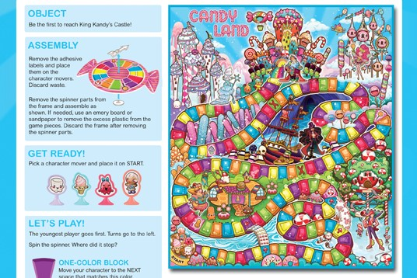

**Prioritize instruction sequence for urgent content**

Fire drill instructions are another example of when to keep the serial position effect in mind. This printout does a notable job by having two of the most important bits of information at the beginning and end. It also utilizes a mnemonic device to help remember the procedure. Sometimes the most effective thing we can do is to put the bottom line upfront. In this example rescuing yourself and anyone else may be the only instructions that really matter.

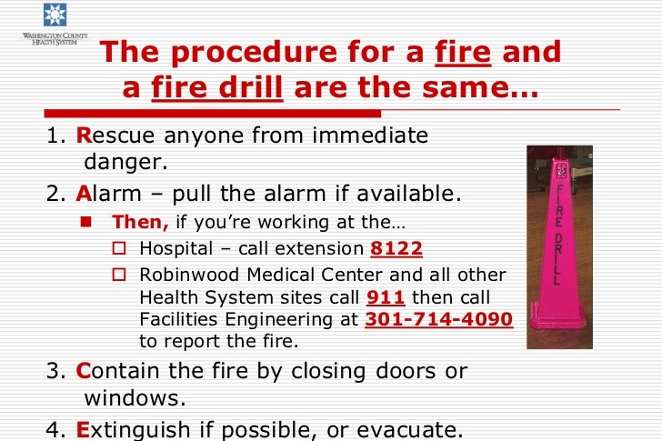

**Purposely shape lesson structure**

Our training and our lessons benefit when we keep the serial position effect in mind. This chart lays out a seven-step process that helps users to plan more traditional lessons in a way that mitigates the middle lull. It uses primacy and recency for point emphasis and employs active engagement in the middle of the lesson to maintain focus and concentration.

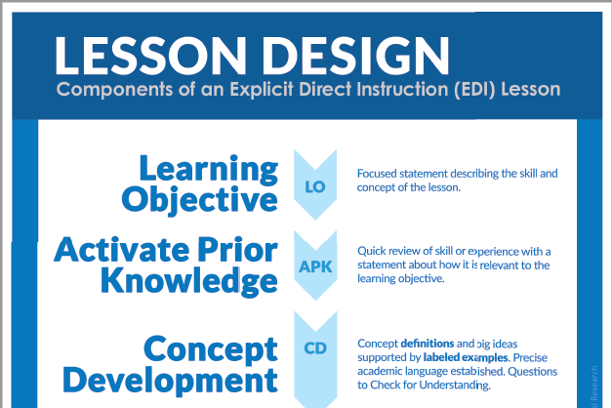

Duane Gregory - WTAMU course 6310 - Summer II - 2020